# Lab Session 10: Version Control

* 1. **Introduction**

Revision control or source control is a way of recording changes to a file or collection of files over time so that you can recall specific versions later. A version control system (or VCS in short) is a tool that records changes to files on a file system.

There are many version control systems out there, but Git is currently the most popular and frequently used, especially for source code management. Version control can actually be used for nearly any type of file on a computer, not only source code.

Version control systems/tools offer several features that allow individuals or a group of people to:

* + - create versions of a project.
    - track changes accurately and resolve conflicts.
    - merge changes into a common version.
    - rollback and undo changes to selected files or an entire project.
    - access historical versions of a project to compare changes over time.
    - see who last modified something that might be causing a problem.
    - create a secure offsite backup of a project.
    - use multiple machines to work on a single project and so much more.

A project under a version control system such as Git will have mainly three sections, namely:

* + - A repository: a database for recording the state of or changes to your project files. It contains all of the necessary Git metadata and objects for the new project. Note that this is normally what is copied when you clone a repository from another computer on a network or remote server.
    - A working directory or area: stores a copy of the project files which you can work on

(make additions, deletions and other modification actions).

* + - A staging area: a file (known as index under Git) within the Git directory that stores information about changes that you are ready to commit save (save the state of a file) or set of files to the repository.

There are two main types of VCSs, with the main difference being the number of repositories:

* + - Centralized Version Control Systems (CVCSs): here each project team member gets their own local working directory, however, they commit changes to just a single central repository.
    - Distributed Version Control Systems (DVCSs): under this, each project team member gets their own local working directory and Git directory where they can make commits. After an individual makes a commit locally, other team members can’t access the changes until he/she pushes them to the central repository. Git is an example of a DVCS.

In addition, a Git repository can be bare (repository that doesn’t have a working directory) or non- bare (one with a working directory). Shared (or public or central) repositories should always be bare – all Github repositories are bare

* 1. **Version Control with Git**

Git is a free and open source, fast, powerful, distributed, easy to use, and popular version control system that is very efficient with large projects, and has a remarkable branching and merging system. It is designed to handle data more like a series of snapshots of a mini filesystem, which is stored in a Git directory.

The workflow under Git is very simple: you make modifications to files in your working directory, then selectively add just those files that have changed, to the staging area, to be part of your next commit.

Once you are ready, you do a commit, which takes the files from staging area and saves that snapshot permanently to the Git directory.

To install Git in Linux, use the appropriate command for your distribution of choice:

$ sudo apt install git [On Debian/Ubuntu]

$ sudo yum install git [On CentOS/RHEL]

After installing Git, it is recommended that you tell Git who you are by providing your full name and email address, as follows:

$ git config --global user.name “username”

$ git config --global user.email “[username@gmail.com”](mailto:username@gmail.com)

To check your Git settings, use the following command.

$ git config --list

* 1. **Create a New Git Repository**

Shared repositories or centralized workflows are very common and that is what we will demonstrate here. For example, we assume that you have been tasked to setup a remote central repository for system administrators/programmers from various departments in your organization, to work on a project called bashscripts, which will be stored under

/projects/scripts/ on the server.

SSH into the remote server and create the necessary directory, create a group called sysadmins (add all project team members to this group e.g user admin), and set the appropriate permissions on this directory.

# mkdir-p /projects/scripts/ # groupadd sysadmins

# usermod -aG sysadmins admin

# chown :sysadmins -R /projects/scripts/ # chmod 770 -R /projects/scripts/

Then initialize a bare project repository.

# git init --bare /projects/scripts/bashscripts

* 1. **Initialize Git Shared Repository**

At this point, you have successfully initialized a bare Git directory which is the central storage facility for the project. Try to do a listing of the directory to see all the files and directories in there:

# ls -la

/projects/scripts/bashscripts/ List Git Shared Repository

* 1. **Clone a Git Repository**

Now clone the remote shared Git repository to your local computer via SSH (you can also clone via HTTP/HTTPS if you have a web server installed and appropriately configured, as is the case with most public repositories on Github), for example:

$ git clone ssh://admin@remote_server_ip:/projects/scripts/bashscripts

To clone it to a specific directory (~/bin/bashscripts), use the command below.

$ git clone ssh://admin@remote_server_ip:/projects/scripts/bashscripts ~/bin/bashscripts

**Clone Shared Git Repository to Local**

You now have a local instance of the project in a non-bare repository (with a working directory), you can create the initial structure of the project (i.e add a README.md file, sub-directories for different categories of scripts e.g recon to store reconnaissance scripts, sysadmin to store sysadmin scripts etc.):

$ cd ~/bin/bashscripts/

$ ls -la

Create Git Project Structure

* 1. **Check a Git Status Summary**

To display the status of your working directory, use the status command which will shows you any changes you have made; which files are not being tracked by Git; those changes that have been staged and so on.

$ git status Check Git Status

* 1. **Git Stage Changes and Commit**

Next, stage all the changes using the add command with the -A switch and do the initial commit. The -a flag instructs the command to automatically stage files that have been modified, and -m is used to specify a commit message:

$ git add -A

$ git commit -a -m "Initial Commit" Do Git commit

* 1. **Publish Local Commits to Remote Git Repository**

As the project team lead, now that you have created the project structure, you can publish the changes to the central repository using the push command as shown.

$ git push origin master

**Push Commit to Central Git Repository**

Right now, your local git repository should be up-to-date with the project central repository (origin), you can confirm this by running the status command once more.

**Check Git Status**

$git status

You can also inform you colleagues to start working on the project by cloning the repository to their local computers.

* 1. **Create a New Git Branch**

Branching allows you to work on a feature of your project or fix issues quickly without touching the code base (master branch). To create a new branch and then switch to it, use the branch and checkout commands respectively.

$ git branch latest

$ git checkout latest

Alternatively, you can create a new branch and switch to it in one step using the checkout command with the -b flag.

$ git checkout -b latest

To check which branch you are in, use branch command (an asterisk character indicates the active branch):

$git branch

Check Active Branch

After creating and switching to the new branch, make some changes under it and do some commits.

$ vim sysadmin/topprocs.sh

$ git status

$ git commit add sysadmin/topprocs.sh

$ git commit -a -m 'modified topprocs.sh'

* 1. **Merge Changes from One Branch to Another**

To merge the changes under the branch test into the master branch, switch to the master branch and do the merge.

$ git checkout master

$ git merge test

Merge Test Branch into Master

If you no longer need a particular branch, you can delete it using the -d switch.

$ git branch -d test

**Download Changes from Remote Central Repository**

Assuming your team members have pushed changes to the central project repository, you can download any changes to your local instance of the project using the pull command.

$ git pull origin OR

$ git pull origin master #if you have switched to another branch Pull Changes from Central Repository

**Inspect Git Repository and Perform Comparisons**

In this last section, we will cover some useful Git features that keep track of all activities that happened in your repository, thus enabling you to view the project history.

The first feature is Git log, which displays commit logs:

$ git log

View Git Commit Logs

Another important feature is the show command which displays various types of objects (such as commits, tags, trees etc...):

$ git show

Git Show Objects

The third vital feature you need to know is the [diff command, used to compare or show difference](https://www.tecmint.com/linux-sdiff-command-examples/) [between](https://www.tecmint.com/linux-sdiff-command-examples/) branches, display changes between the working directory and the index, changes between two files on disk and so much more.

For instance to show the difference between the master and latest branch, you can run the following command.

$ git diff master latest

**LAB EXERCISE:**

Q1. Perform the following task.

1. Create a Git repository name “CS and SE”
2. Clone a Git Repository
3. Check a Git Status Summary
4. Git Stage Changes and Commit

**Install Git using following command:**

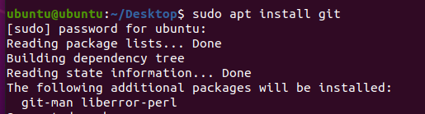

**Check Git version:**



**Configure Git for future use:**



**Step 2: To verify the configured changes:**

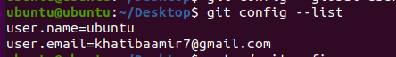

**For Reading contents written in Git file:**

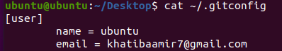

**Step 3: For Repository, first login to your GitHub account and create a new repository. Upload some files into that repository. After that, make a directory with same name as your repository in your system and change pwd to that new directory.**

**To initialize Git in that directory, use command: git init**

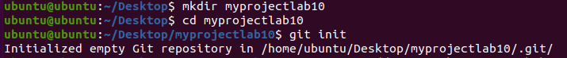

**Step 4: Now we will set up the remote, which tells git where the repository is located.**

**git remote add origin** [**https://github.com/your_username/myproject.git**](https://github.com/your_username/myproject.git)



**Then add a user group:**

**With getent command, you can see whether the group is created or not. The syntax for next command is: sudo usermod -aG <new-group-name> <user-name>**

**This command will add the user “test1” to the newly created group.**

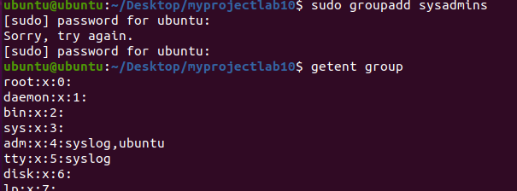

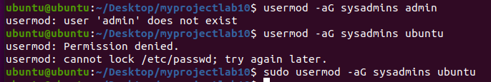

**To see that whether the user has been added to the group, use following command.**



**Then find out the complete path of your current directory using pwd command.**



**Then we have to change owner of the directory to the new user-group that we created i.e., sysadmins.**

**The following command changes the owner of newly created directory to sysadmins.**

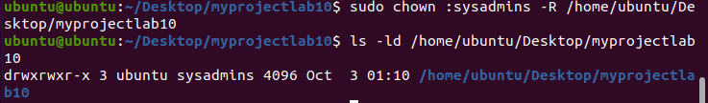

**The following command changes the file permissions for the myproject directory. The flag 770 indecates that owner and the group will have all rights while the other users (o) will not have any rights on the directory and its files. To see the difference, compare the above screenshot with the current screenshot.**

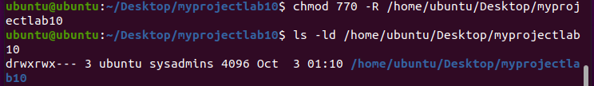

**Then initialize a bare project repository.**

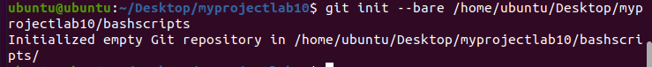

**At this point, you have successfully initialized a bare Git directory which is the central storage facility for the project. Try to do a listing of the directory to see all the files and directories in there:**

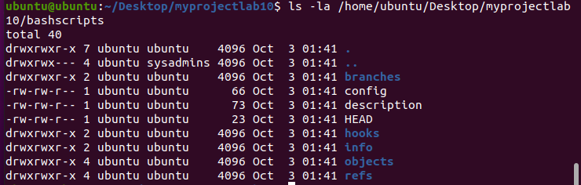

**Cloning Git Repository:**